**Adding a Breakpoint in Devtools**

In order to add a breakpoint at any place in Devtools, click the line number in the column to the left of the source code.

Start **app.js** in Inspect Break mode (**--inspect-brk**) , connect Chrome Devtools, ensure that the "Sources" tab is selected and then click line 3 in **app.js**. The line number (3) will become backlit with a blue arrow:

a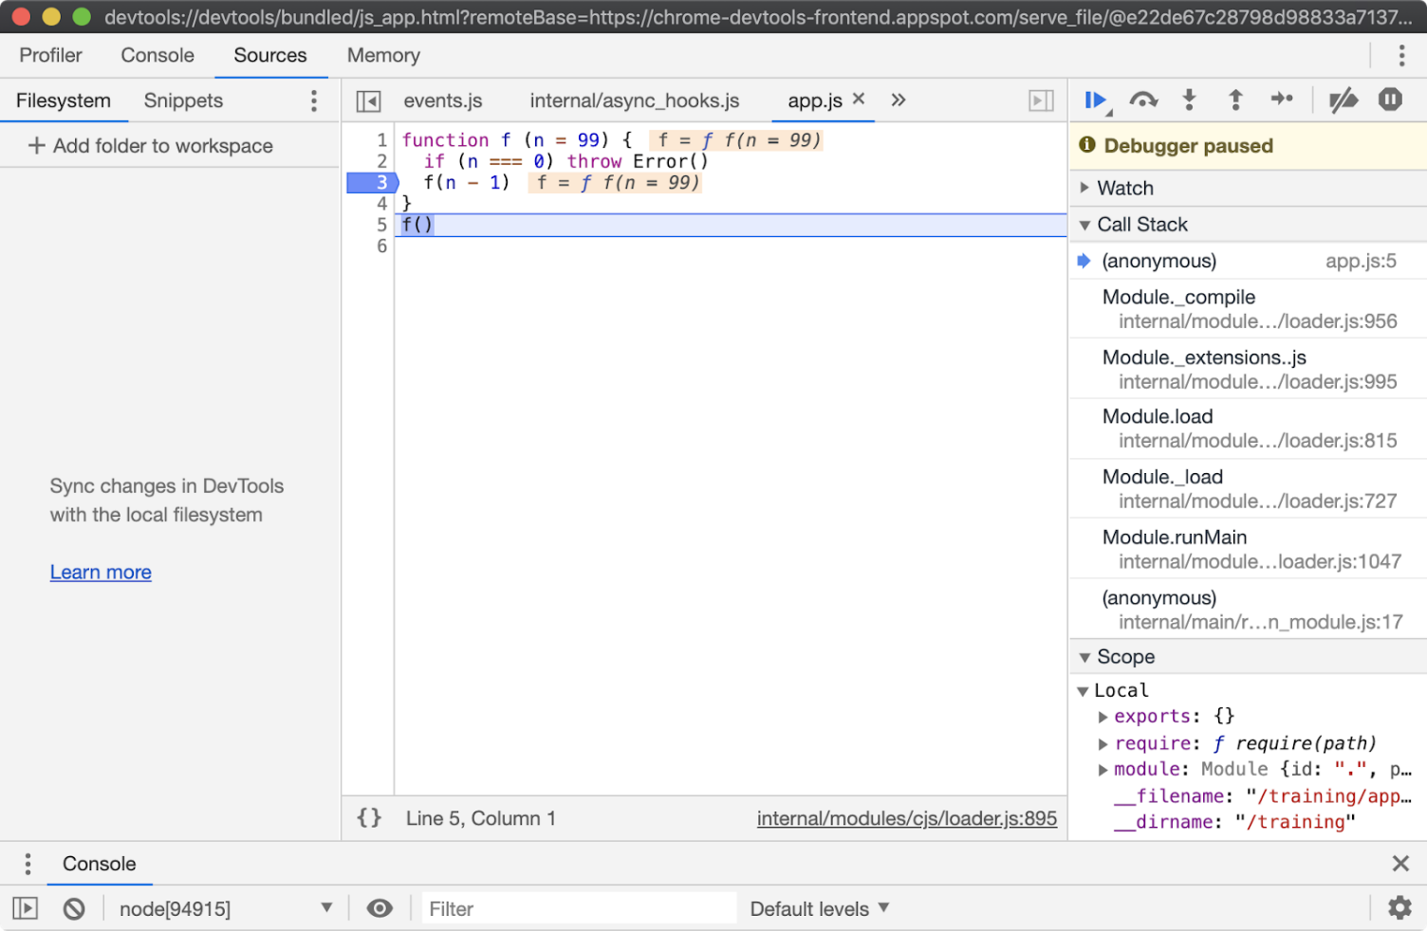

Clicking the blue play button in the right column will cause program execution to resume, the **f** function will be called and the runtime will pause on line 3:

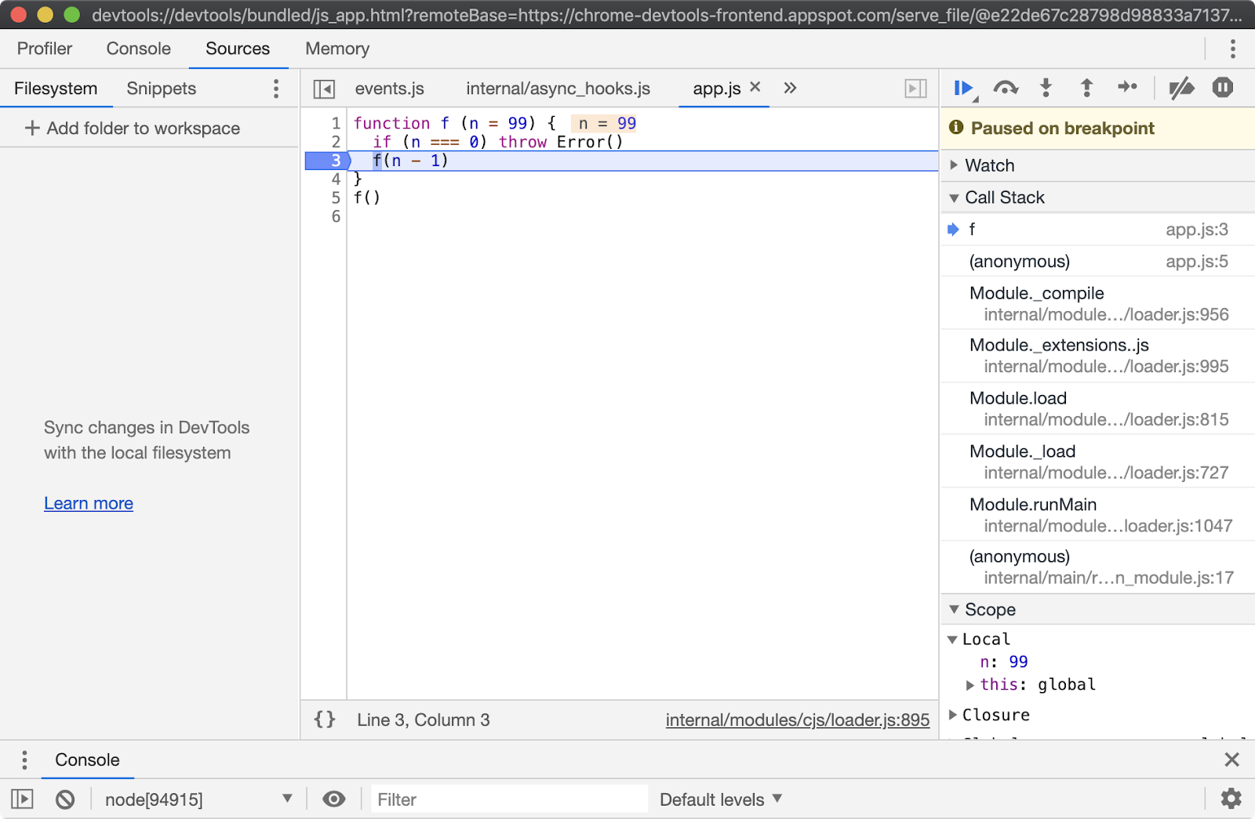

From here the value of **n** can be seen, highlighted in beige on line 1. The Call Stack can be explored over in the right hand column and state can be analyzed by hovering over local variables and looking in the Scope panel of the right hand column, located beneath the CallStack panel.